Walk for Creation
A Guide for Parishes
The First Step
Following on from the successful Climate Change walk in the Salford Deanery before COP26 last October, a number of other parishes and deaneries have expressed an interest in organising a similar ‘Walk for Creation’.
This guide is some simple steps you might want to think about ahead of the walk and some suggested reflections for your stopping points.
These stopping points can be a few metres apart on parish ground or a few miles apart at different churches on your route.
Your route and the distance you want to cover is down to your parish groups.
The important thing is to create an atmosphere that is welcoming to all different accessibility levels, even on a long walk this can be created by announcing the estimated times of your stopping points.
The reflections are designed to show how our faith can impact the way we look at the world and encourage those attending to pay more care to our own local surroundings.
You may wish to change these reflections to better suit your own area.
We would love to hear about your walk and the feedback you get. Please let us know your plans at communications@dioceseofsalford.org.uk
Top Tips
Before the walk:
- Decide on the route, length of your walk and any stopping points.
- Complete risk assessments for your walk (an example can be found at https://www.dioceseofsalford.org.uk/services/health-and-safety/)
- Advertise and promote your walk in your parish. Ask parishioners if they would like to bring someone with them. This is a great way to reach out to members of your local community.
- You may also like to extend the invite to other faith leaders in your area.
- Identify who will open and lead the reflections (if it’s not you).
- Arrange for refreshment and comfort facilities to be available at your stopping and/or end points.

After the walk:
- Make sure you get the names of anyone who doesn’t attend the parish and you can thank them for attending.
Introduction
Short introduction and Welcome
As we begin our walk, let us allow these words from Pope Francis to raise our spirits in hope: “I invite everyone to renewed hope, for hope “speaks to us of something deeply rooted in every human heart, independently of our circumstances and historical conditioning.
Hope speaks to us of a thirst, an aspiration, a longing for a life of fulfilment, a desire to achieve great things, things that fill our heart and lift our spirit to lofty realities like truth, goodness and beauty, justice, and love…
Hope is bold; it can look beyond personal convenience, the petty securities and compensations which limit our horizon, and it can open us up to grand ideals that make life more beautiful and worthwhile”.
Let us continue, then, to advance along the paths of hope.”

Psalm 104 (1-9):
Bless the Lord, O my soul.
O Lord my God, you are very great.
You are clothed with honour and majesty, wrapped in light as with a garment.
Response: Send forth your Spirit and renew the face of the Earth

You stretch out the heavens like a tent,
You set the beams of your chambers on the waters,
You make the clouds your chariot, you ride on the wings of the wind, you make the winds your messengers, fire and flame your ministers.
Response: Send forth your Spirit and renew the face of the Earth

You set the earth on its foundations, so that it shall never be shaken.
You cover it with the deep as with a garment; the waters stood above the mountains.
At your rebuke they flee; at the sound of your thunder they take to flight.
Response: Send forth your Spirit and renew the face of the Earth

They rose up to the mountains,
Ran down to the valleys to the place that you appointed for them.
You set a boundary that they may not pass, so that they might not again cover the earth.
Response: Send forth your Spirit and renew the face of the Earth

Opening Prayer
Lord our God,
Fill our hearts and our minds as we walk this day.
Help us to see anew the beauty of the world that you give us, the damage that our actions and lifestyles have done to it, the impact those actions have had on the poorest of the world.
Renew in us the determination to change our lives and strengthen in us the will to make individual sacrifices to bring about communal change.
We make our prayer through Jesus Christ your son, whose sacrifice unites us to you and gives us the example of love to follow, in the unity of the Holy Spirit.
Amen.

Reflection One
In this first reflection we focus on the cry of the earth, remembering the gift that God has given us in the world around us, the beauty that is before us every day, if only we had the eyes to see.
Pope Francis helps us to see that what is at stake in the environmental crisis has to do with how we understand ourselves, God, and His creation.
Pope Francis and Laudato Si’ (160)
“When we ask ourselves what kind of world we want to leave behind, we think in the first place of its general direction, its meaning, and its values.
Unless we struggle with these deeper issues, I do not believe that our concern for ecology will produce significant results.
But if these issues are courageously faced, we are led inexorably to ask other pointed questions: What is the purpose of our life in this world? Why are we here? What is the goal of our work and all our efforts? What need does the earth have of us?
It is no longer enough, then, simply to state that we should be concerned for future generations.
We need to see that what is at stake is our own dignity.
Leaving an inhabitable planet to future generations is, first and foremost, up to us.
The issue is one which dramatically affects us, for it has to do with the ultimate meaning of our earthly sojourn.”
Reflect
How much time do I spend each day noticing beauty in the world around me?
In what ways is my life dominated by “what is most convenient” rather than “what is right”?

Psalm 104 (10-15)
You make springs gush forth in the valleys;
They flow between the hills, Giving drink to every wild animal;
The wild asses quench their thirst.
Response: Send forth your Spirit and renew the face of the Earth

By the streams the birds of the air have their habitation;
They sing among the branches.
From your lofty abode you water the mountains;
The earth is satisfied with the fruit of your work.
Response: Send forth your Spirit and renew the face of the Earth

You cause the grass to grow for the cattle,
And plants for people to use,
To bring forth food from the earth,
And wine to gladden the human heart,
Oil to make the face shine,
And bread to strengthen the human heart.
Response: Send forth your Spirit and renew the face of the Earth

Let us Pray
Loving God,
We praise your name with all you have created.
You are present in the whole universe, and in the smallest of creatures.
We acknowledge the responsibilities you have placed upon us as stewards of your creation.
May the Holy Spirit inspire all political leaders as they seek to embrace the changes needed to foster a more sustainable society.
Instil in them the courage and gentleness to implement fairer solutions for the poorest and most vulnerable, and commit their nations to the care of our Common Home.
We ask this through Our Lord Jesus Christ your Son,
Amen
CAFOD COP26 Prayer

As we continue our journey, let us open our eyes to the beauty around and reflect on our own commitment to the care of our Common Home.

Reflection Two
In this second reflection, we focus on the cry of the poor, remembering and praying for our brothers and sisters who are struggling to find food and shelter.
What does Pope Francis say?
Pope Francis reminds us in his 2021 message for World Day of the Poor that the poor are not people “outside” our communities, but brothers and sisters whose sufferings we should share, in an effort to alleviate their difficulties, restore their lost dignity, and ensure their necessary social inclusion.
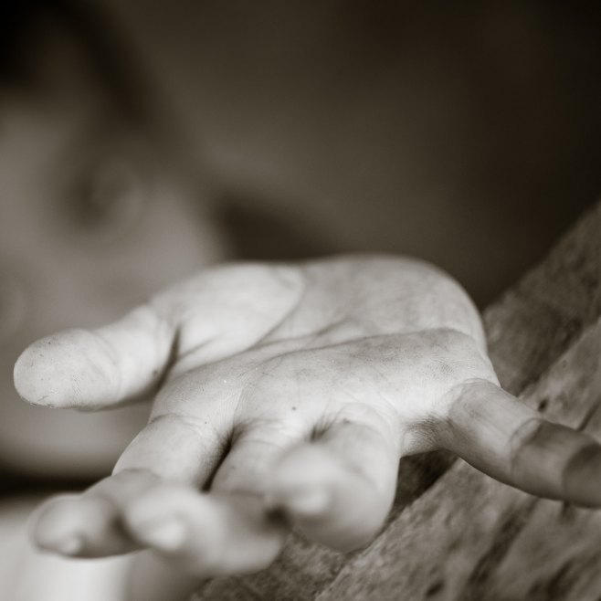
“In everything, Jesus teaches that poverty is not the result of fate, but a concrete sign pointing to his presence among us. We do not find Him when and where we want, but see Him in the lives of the poor, in their sufferings and needs, in the often inhuman conditions in which they are forced to live.
“As I never tire of repeating, the poor are true evangelizers, for they were the first to be evangelized and called to share in the Lord's joy and his kingdom (cf. Mt 5:3).
“The poor, always and everywhere, evangelize us, because they enable us to discover in new ways the true face of the Father. They have much to teach us.”

Reflect
How do my choices affect the lives of other people? Am I concerned about the poor who live nearby? The poor who live far away? What am I willing to change in my life to make a difference to the lives of others?
Why not visit https://www.caritassalford.org.uk/to find out more about how you can care for others?
Psalm 104 (16-23)
The trees of the Lord are watered abundantly,
The cedars of Lebanon that he planted.
In them the birds build their nests;
The stork has its home in the fir trees.
Response: Send forth your Spirit and renew the face of the Earth

The high mountains are for the wild goats;
The rocks are a refuge for the coneys.
You have made the moon to mark the seasons;
The sun knows its time for setting.
Response: Send forth your Spirit and renew the face of the Earth

You make darkness, and it is night,
When all the animals of the forest come creeping out.
The young lions roar for their prey,
Seeking their food from God.
Response: Send forth your Spirit and renew the face of the Earth

When the sun rises, they withdraw and lie down in their dens.
People go out to their work and to their labour until the evening.
Response: Send forth your Spirit and renew the face of the Earth

Let us pray
Loving God,
Creator of Heaven, Earth, and all therein contained.
Open our minds and touch our hearts, so that we can be part of Creation, your gift.
Be present to those in need in these difficult times, especially the poorest and most vulnerable.
Help us to show creative solidarity as we confront the consequences of the global pandemic.
Make us courageous in embracing the changes required to seek the common good.
Now more than ever, may we all feel interconnected and interdependent.
Enable us to succeed in listening and responding to the cry of the Earth and the cry of the poor.
May their current sufferings become the birth-pangs of a more fraternal and sustainable world.
We pray through Christ our Lord, under the loving gaze of Mary Help of Christians, Amen
Pope Francis – Common Prayer for Earth and Humanity

As we continue on our journey, we pray for those people whose home is on the streets and who do not know where they will sleep tonight, whether due to poverty, family break-down, mental health, addiction problems or other complex reasons.

Reflection Three
In this third reflection we focus on the need to respond to the various crises in our world. How we respond both to the cry of the earth and the cry of the poor must be inspired by our encounter with Jesus Christ, who comes to save us. Pope Francis reminds us to be protectors of creation, protectors of God’s plan, protectors of one another, and the environment.
What does Pope Francis say?
As Pope Francis reminds us in Laudato Si’: ‘The external deserts in the world are growing, because the internal deserts have become so vast’.
For this reason, the ecological crisis is also a summons to profound interior conversion.
It must be said that some committed and prayerful Christians, with the excuse of realism and pragmatism, tend to ridicule expressions of concern for the environment.
Others are passive; they choose not to change their habits and thus become inconsistent.
So, what they all need is an “ecological conversion”, whereby the effects of their encounter with Jesus Christ become evident in their relationship with the world around them.
Living our vocation to be protectors of God’s handiwork is essential to a life of virtue; it is not an optional or a secondary aspect of our Christian experience.”
Reflect
Do I live an integrated life as a Christian?
In what areas of my life do I most need conversion?

Closing Prayer
Christ has no body but yours,
No hands, no feet on earth but yours,
Yours are the eyes with which He looks Compassion on this world,
Yours are the feet with which He walks to do good,
Yours are the hands, with which He blesses all the world.
Yours are the hands, yours are the feet,
Yours are the eyes, you are His body. Christ has no body now but yours,
No hands, no feet on earth but yours,
Yours are the eyes with which he looks compassion on this world.
Christ has no body now on earth but yours.
— St. Teresa of Ávila

Diocesan Prayer for Our Common Home:
All powerful God, you created all things, and you are present throughout the universe and in every creature,
You embrace with your tender love all that exists.
Pour out upon us the power of your love, so that we may have the strength and courage to protect all life and the beauty of our world, preserving it from pollution and destruction.
Fill us with your peace, that we may live as brothers and sisters, harming no one,
And caring for the Earth, our common home.
Teach us to discover the worth of every creature on this earth,
Let us protect those at risk and in danger,
Encourage us as we seek justice, love and peace.
Stay with us each day, with the power of your grace.
Through Christ our Lord,
Amen.

